Government College of Engineering, Nagpur



Department of Computer Science & Engineering

3rd Year 5th Semester

Academic Year - 2020-21

Project - Movie Ticket Booking System

Submitted By: Query Coder’s

Name | Roll No. | Department
Roshan Bonde (Leader) | 54 | CSE
Aman Sharma | 6 | CSE
Vishal Yadav | 73 | CSE
Rohit Ramteke | 52 | CSE

Government College of Engineering, Nagpur

Department of Computer Science & Engineering


DECLARATION

We hereby declare that this project based lab report entitled “Movie ticket booking System” has been prepared by us in Computer Science and Engineering during the academic
year 2020 - 21.

We also declare that this project based lab report is of our own effort and it has not
been submitted to any other university.

Date: 25 / 11 / 2020

Place: Nagpur

ACKNOWLEDGEMENT

It is great pleasure for me to express my gratitude to our honourable HOD Dr.Latesh Bhagat for giving the opportunity and platform with facilities in accomplishing the project based laboratory report.I express sincere gratitude to our HOD for her administration towards academic growth and also providing us the efficient faculty and facilities to bring our ideas into reality.

Finally,it is pleased to acknowledge the indebtedness to all those who devoted themselves directly or indirectly to make this project report success.

PROJECT ASSOCIATES

Name | Roll No. | Department
Roshan Bonde (Leader) | 54 | CSE
Aman Sharma | 6 | CSE
Vishal Yadav | 73 | CSE
Rohit Ramteke | 52 | CSE

TABLE OF CONTENTS

Acknowledgment ………………………………………………………………. 4
Abstract ………………………………………..……………………………….. 6
Introduction ……………………………………………………………………. 7
Project Description ……………………………………………………...…....... 8
List of Entities & Attributes ……………………………………………………. 10
ER Diagram(Conceptual Model) ......................................................................... 12
Create & Insert SQL Queries …………………………………………………... 16
SQL Queries related to Report Generation …………………………………..... 19
Project Based Screenshot ……………………………………………………... 22
Conclusion ……………………………………………………………………... 24

ABSTRACT

The Movie Ticket Booking System facilitates the users to enquire about the

recent movies available movies,booking and cancellation of movie tickets according

to theatre type and class type,enquire about the status of the booked tickets, etc.

The aim of this project is to design a website that gives an easy platform for

people to get details of trending films and to get movie tickets in the

easiest possible way making it simple for all to buy tickets from anytime

and anywhere.

This project contains introduction to movie ticket booking system.It is

computerized way of reserving the seats of movie in advanced.This online movie ticket

booking system can make the process of booking movie tickets much easier than ever

before.Then this project contains entity relationship model diagram based on movie

ticket booking system an introduction to relational model also example of some sql

queries to retrieve data from the database of this system.
INTRODUCTION

Database is an organized collection of data. The data is typically organized to model aspects of reality in a way that supports processes requiring information. A DBMS makes it possible for end users to create, read, update and delete data in a database. The DBMS essentially serves as an interface between the database and end users or application programs, ensuring that data is consistently organized and remains easily accessible. The DBMS manages three important Things: the data, the database engine that allows data to be accessed, locked or modified and the database schema, which defines the database’s logical structure. These three foundational elements help provide concurrency, security , data integrity and uniform administration procedures. The DBMS can offer both logical and physical data independence. That means it can protect users and applications from needing to know where data is stored or having to be concerned about changes to the physical structure of data.

The main purpose of maintaining a database for Movie Ticket Booking System is to reduce the manual errors involved in the bookings and cancellation of tickets and make it convenient for the customers and the providers to maintain the data about their customers and also about the seats available at them. Due to automation many loopholes that exist in the manual maintenance of the records can be removed. The speed of obtaining and processing the data will be fast. For future expansion the proposed system can be web enabled so that clients can make various enquiries about movie ticket booking. Due to this, sometimes a lot of problems occur and they are facing many disputes with the customers. To solve the above problem,we design a database which includes customer details, availability of movie seats, etc.
PROJECT DESCRIPTION

This project is about creating a webapp for movie ticket booking system. The movie ticket booking system allows the user to do enquiry and get information about the trending movies and get to know about availability of seats for that movie according to theatre type,class type etc. This website will provide users an easy way for booking and cancellation of movie tickets, enquire about the status of booked tickets, provide feedback about the system, etc. Also in this ticket booking webapp all types of payment methods are accepted. There is a feedback form also in this webapp through which users can express their views openly to us about our system and give their valuable suggestion about the system functioning.

Also there is an admin dashboard through which the system providers can keep track of functioning of the system. Through this admin dashboard system providers can see bookings of all movies and make new entries of movies according to new releases and edit data also delete booking in some cases. Also through this admin dashboard system providers keep track of the number of bookings and also maintains user feedback given by users of this system. Also through this admin dashboard system providers keep track of recent releases of movies and provide the same information to the users and also keep track of recent booking of the users.Also at the end of payment users get e-ticket containing details about the movie time, theatre type, class type etc.
LIST OF ENTITIES & ATTRIBUTES

Entities | Attributes
bookingtable | bookingID  movieID  bookingTheatre  bookingType  bookingDate  bookingTime  bookingFName  bookingLName  bookingPNumber  bookingEmail  amount  ORDERID  DATE-TIME
feedbacktable | msgID  senderfName  senderlName  sendereMail  senderfeedback
movietable | movieID  movieImg  movieTitle  movieGenre  movieDuration  movieRelDate  movieDirector  movieActors  mainhall  viphall  privatehall

users | id  username  name  password

ER DIAGRAM(CONCEPTUAL MODEL)

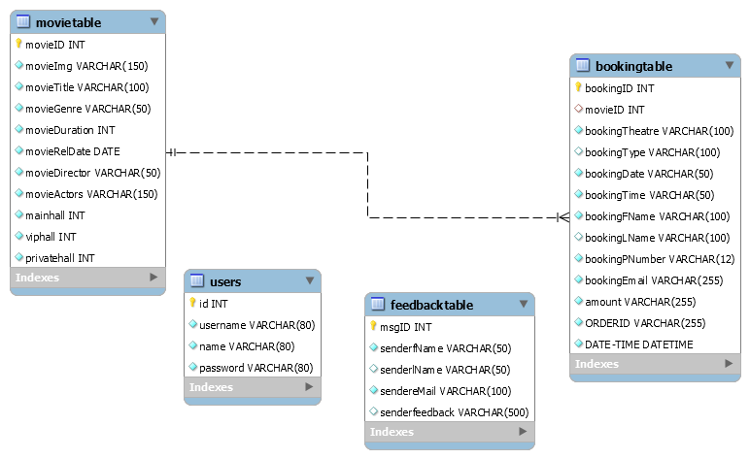

CREATE & INSERT SQL QUERIES

Create Table Queries:

- bookingtable

Query:
CREATE TABLE `bookingtable` (
`bookingID` int(11) NOT NULL,
`movieID` int(11) DEFAULT NULL,
`bookingTheatre` varchar(100) NOT NULL,
`bookingType` varchar(100) DEFAULT NULL,
`bookingDate` varchar(50) NOT NULL,
`bookingTime` varchar(50) NOT NULL,
`bookingFName` varchar(100) NOT NULL,
`bookingLName` varchar(100) DEFAULT NULL,
`bookingPNumber` varchar(12) NOT NULL,
`bookingEmail` varchar(255) NOT NULL,
`amount` varchar(255) NOT NULL,
`ORDERID` varchar(255) NOT NULL,
`DATE-TIME` datetime NOT NULL DEFAULT current_timestamp()
) ENGINE=InnoDB DEFAULT CHARSET=latin1;

- feedbacktable

Query:
CREATE TABLE `feedbacktable` (
`msgID` int(12) NOT NULL,
`senderfName` varchar(50) NOT NULL,
`senderlName` varchar(50) DEFAULT NULL,
`sendereMail` varchar(100) NOT NULL,
`senderfeedback` varchar(500) DEFAULT NULL
) ENGINE=InnoDB DEFAULT CHARSET=latin1;

- movietable

Query:
CREATE TABLE `movietable` (
`movieID` int(11) NOT NULL,
`movieImg` varchar(150) NOT NULL,
`movieTitle` varchar(100) NOT NULL,
`movieGenre` varchar(50) NOT NULL,
`movieDuration` int(11) NOT NULL,
`movieRelDate` date NOT NULL,
`movieDirector` varchar(50) NOT NULL,
`movieActors` varchar(150) NOT NULL,
`mainhall` int(11) NOT NULL,
`viphall` int(11) NOT NULL,
`privatehall` int(11) NOT NULL
) ENGINE=InnoDB DEFAULT CHARSET=latin1;

- users

Query:
CREATE TABLE `users` (
`id` int(11) NOT NULL,
`username` varchar(80) NOT NULL,
`name` varchar(80) NOT NULL,
`password` varchar(80) NOT NULL
) ENGINE=InnoDB DEFAULT CHARSET=latin1;

Insert Queries:

- booking table

INSERT INTO `bookingtable` (`bookingID`, `movieID`, `bookingTheatre`,`bookingType`, `bookingDate`, `bookingTime`, `bookingFName`, `bookingLName`, `bookingPNumber`, `bookingEmail`,`amount`, `ORDERID`,`DATE-TIME`) VALUES (38, 1, 'private-hall', '7d', '13-3', '15-00', 'Rajat', 'Kulkarni', '7438344524', 'robin@gmail.com', '200.00', 'ORD74294887', '2020-11-25 18:07:24');

- feedbacktable

INSERT INTO `feedbacktable` (`msgID`, `senderfName`, `senderlName`, `sendereMail`, `senderfeedback`) VALUES (1, 'Ahmed', 'Ali', 'Ahmed@mail.com', 'Hello first');

- movietable

INSERT INTO `movietable` (`movieID`, `movieImg`, `movieTitle`, `movieGenre`, `movieDuration`, `movieRelDate`, `movieDirector`, `movieActors`, `mainhall`, `viphall`, `privatehall`) VALUES (1, 'img/movie-poster-1.jpg', 'Captain Marvel', ' Action, Adventure, Sci-Fi ', 220, '2018-10-18', 'Anna Boden, Ryan Fleck', 'Brie Larson, Samuel L. Jackson, Ben Mendelsohn', 0, 0, 0);

- users

INSERT INTO `users` (`id`, `username`, `name`, `password`) VALUES (1, '123', 'Aman', '123');

PROJECT BASED SCREENSHOT

Webapp Homepage
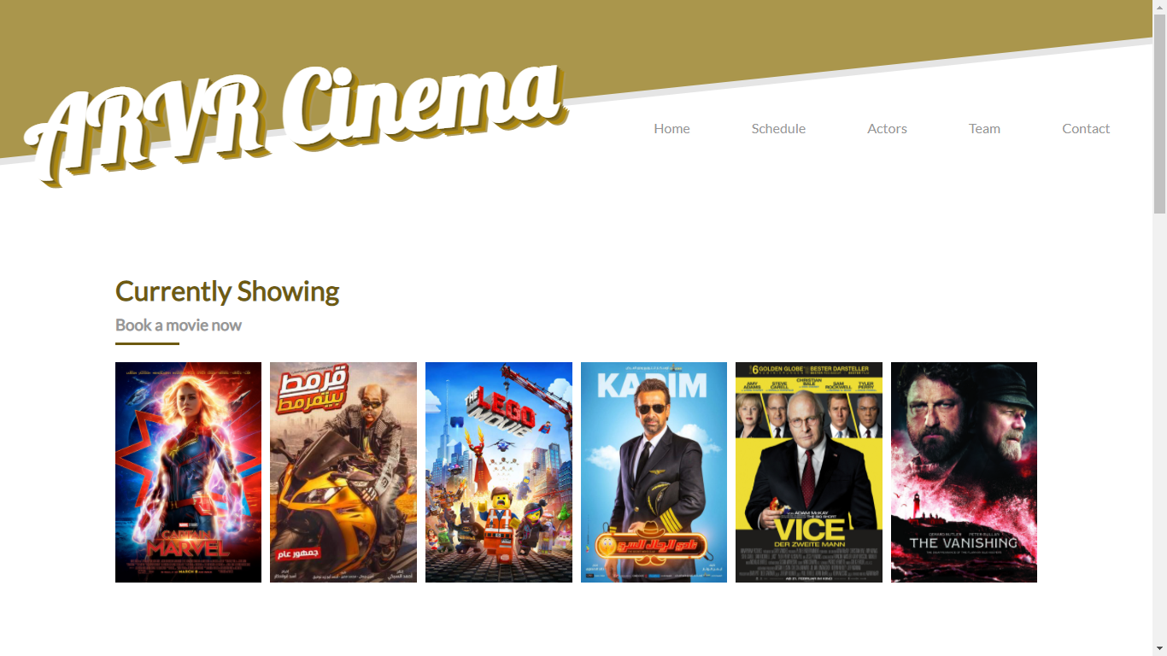

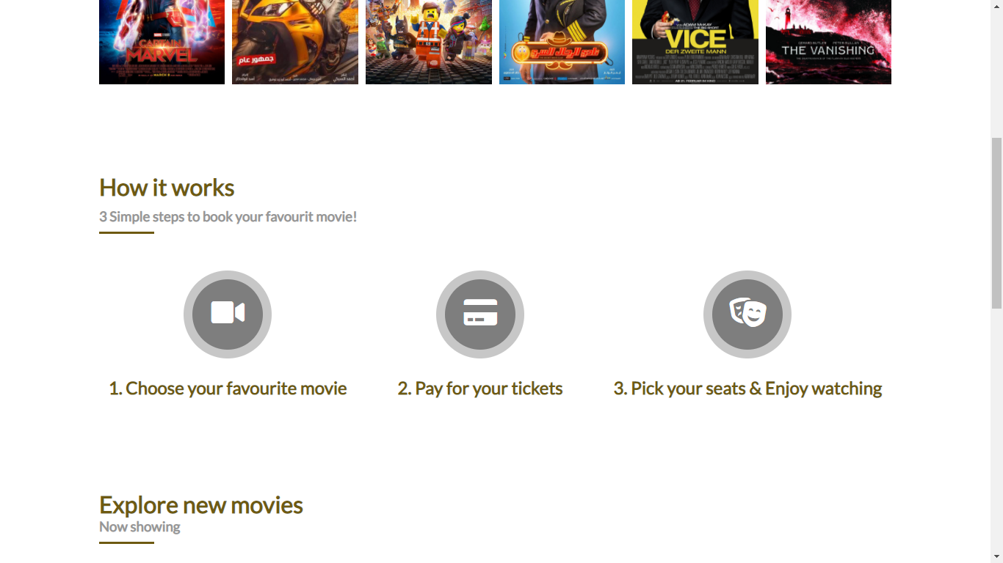

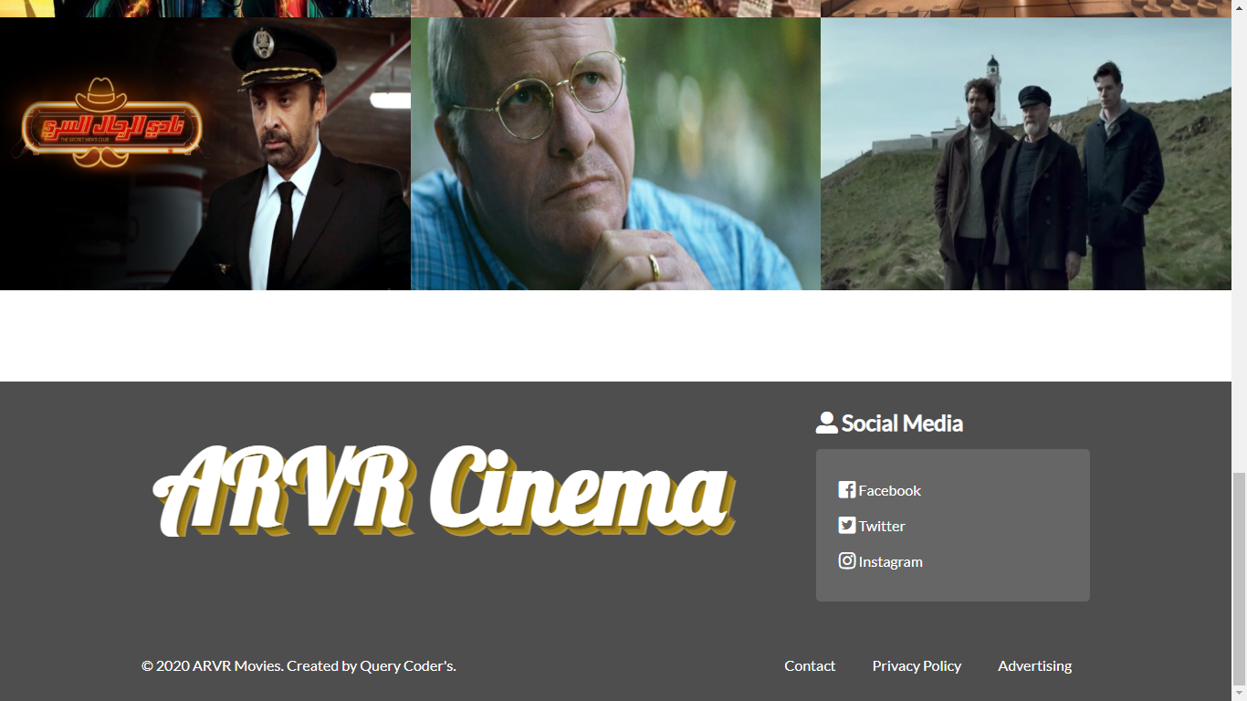

Webapp Ticket Booking Page
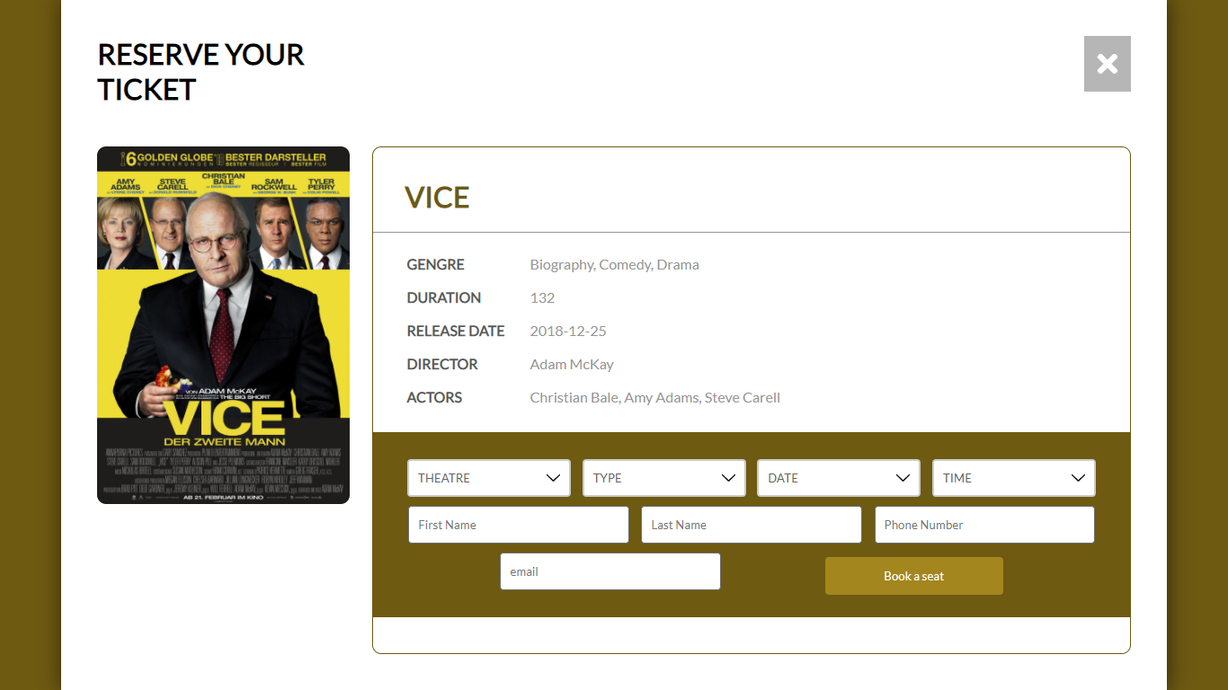

Webapp Payment Page
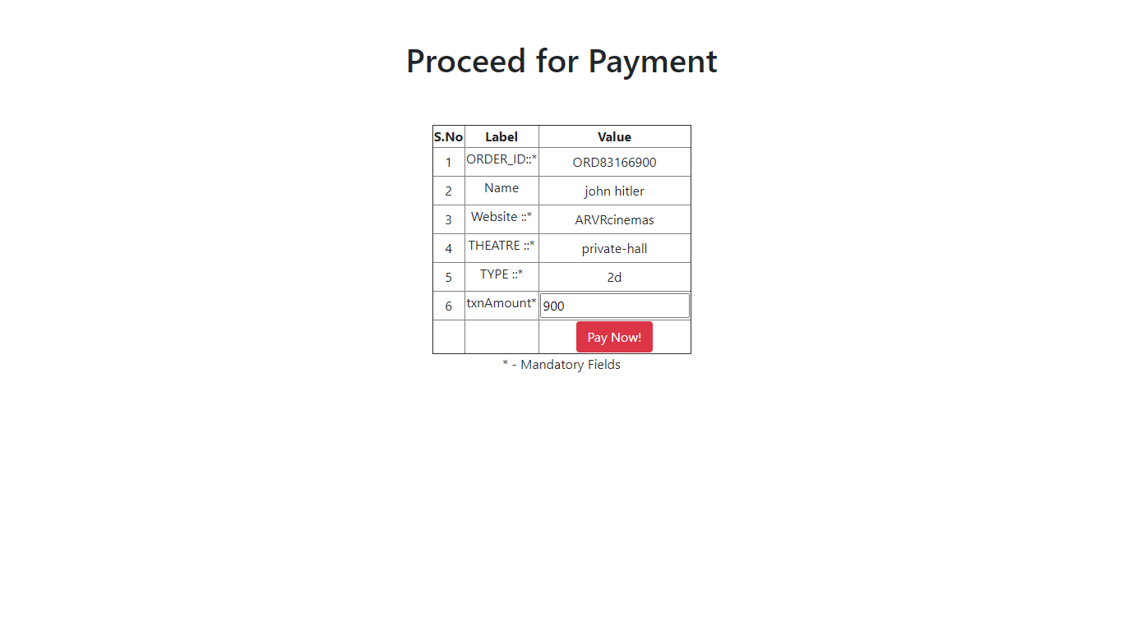

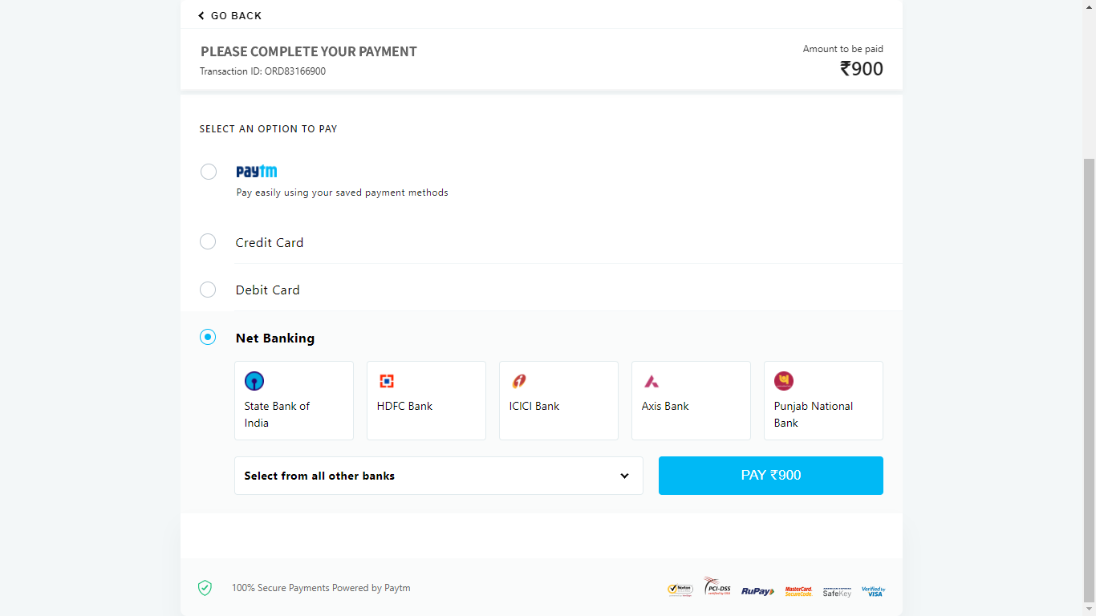

Webapp Reciept Page
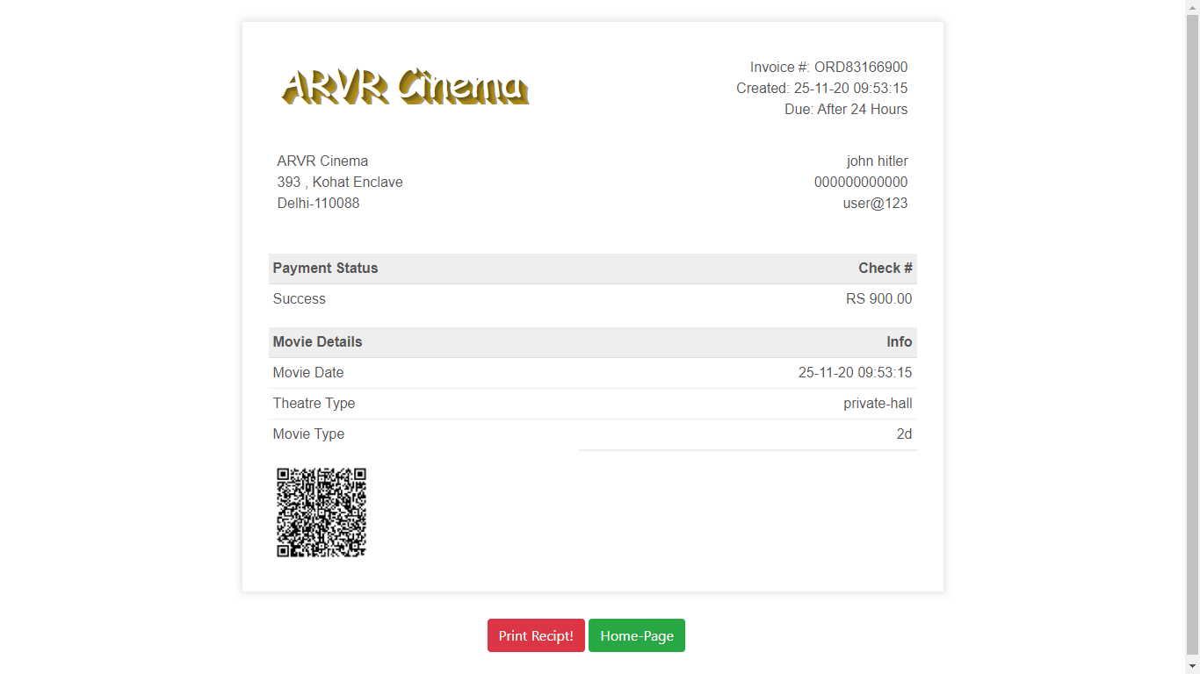

Admin Dashboard

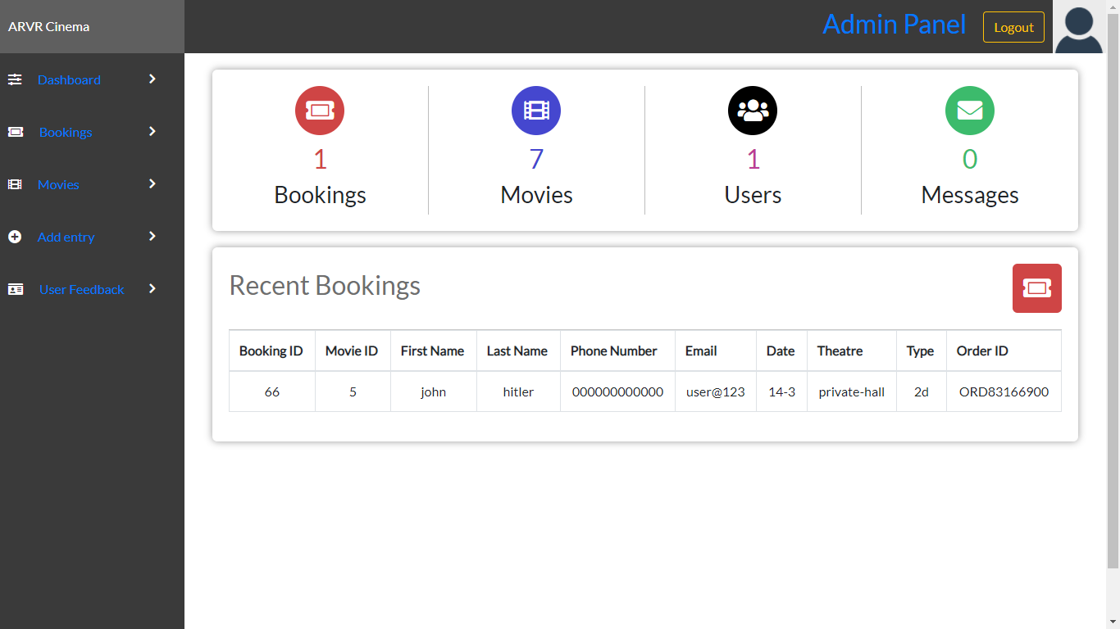

Admin Booking Details Page
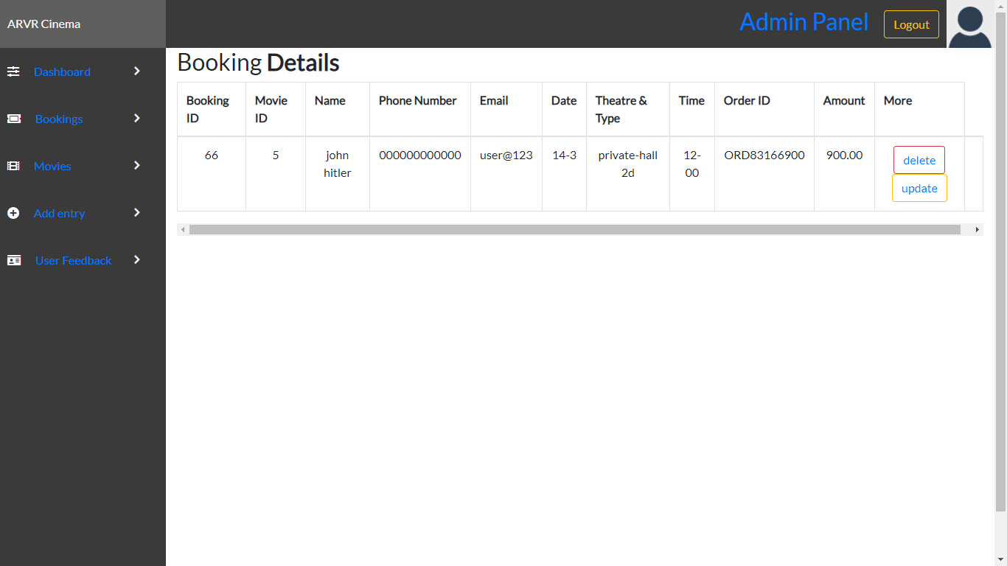

Admin Movie Details Page
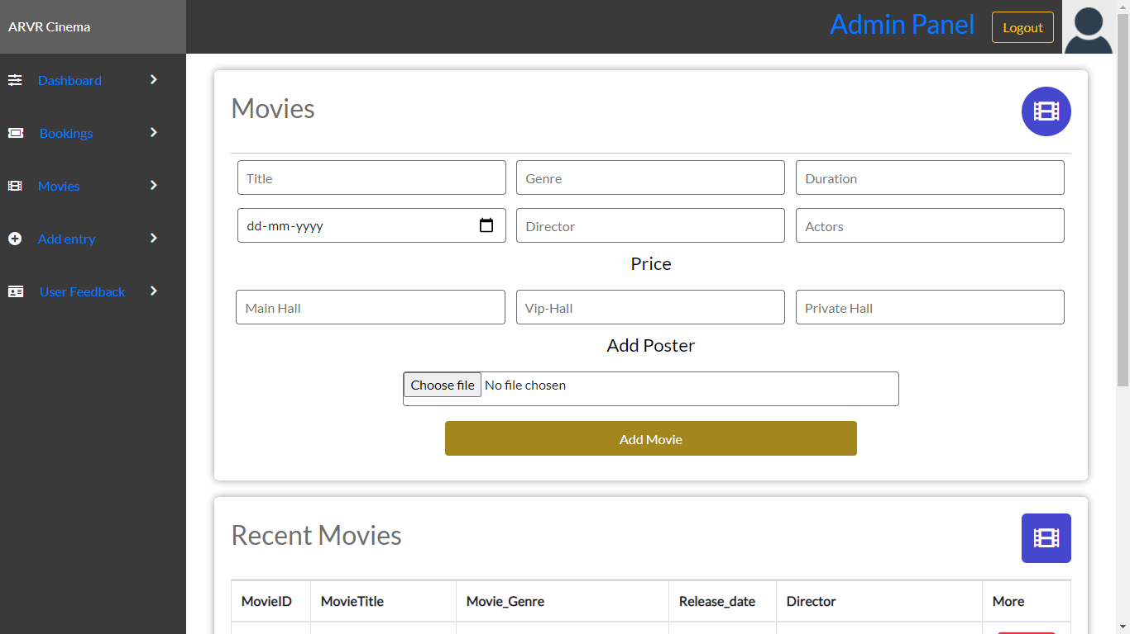

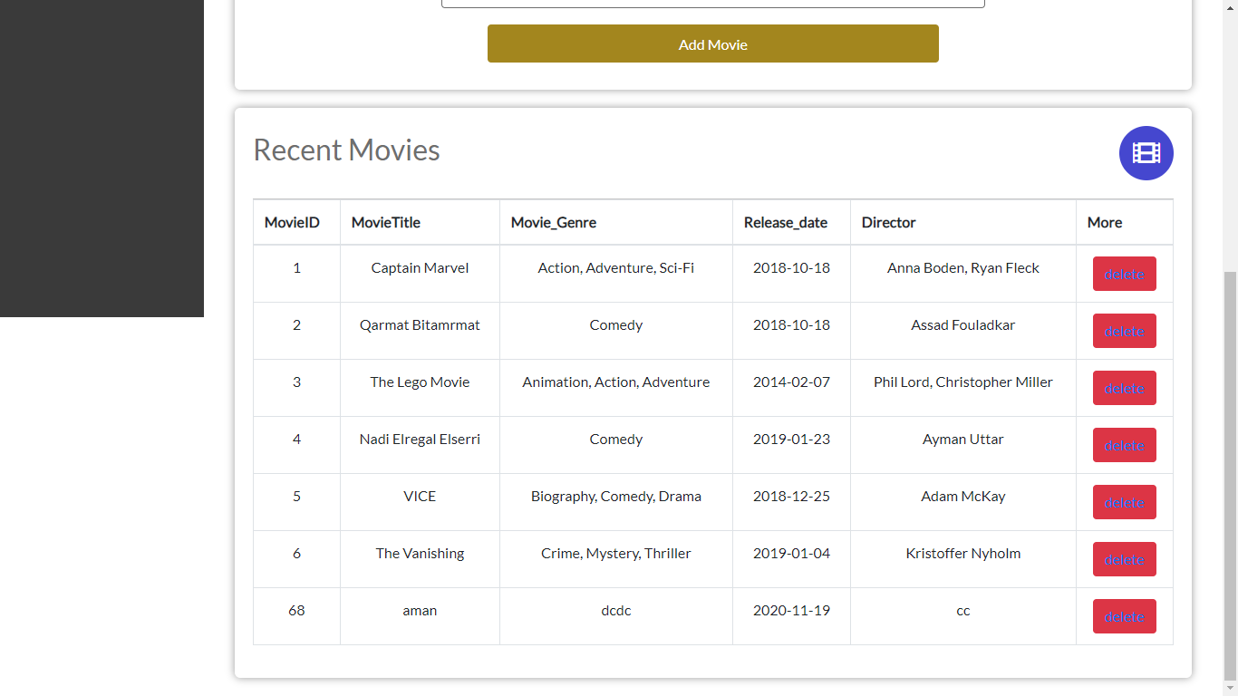

Admin Add Movie Page
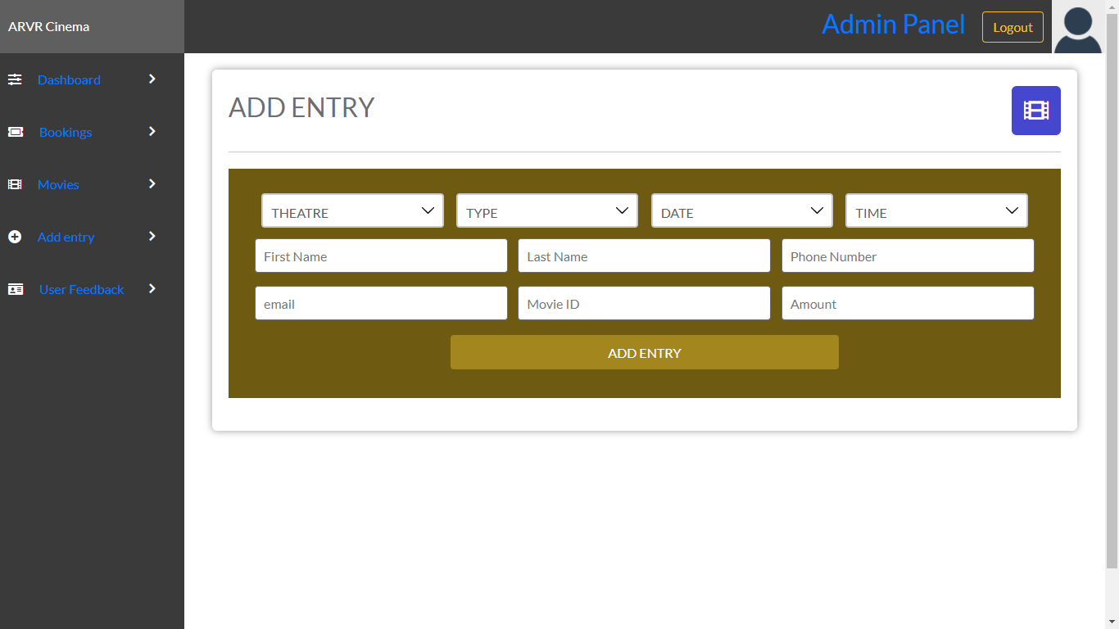

Admin User Feedback Page
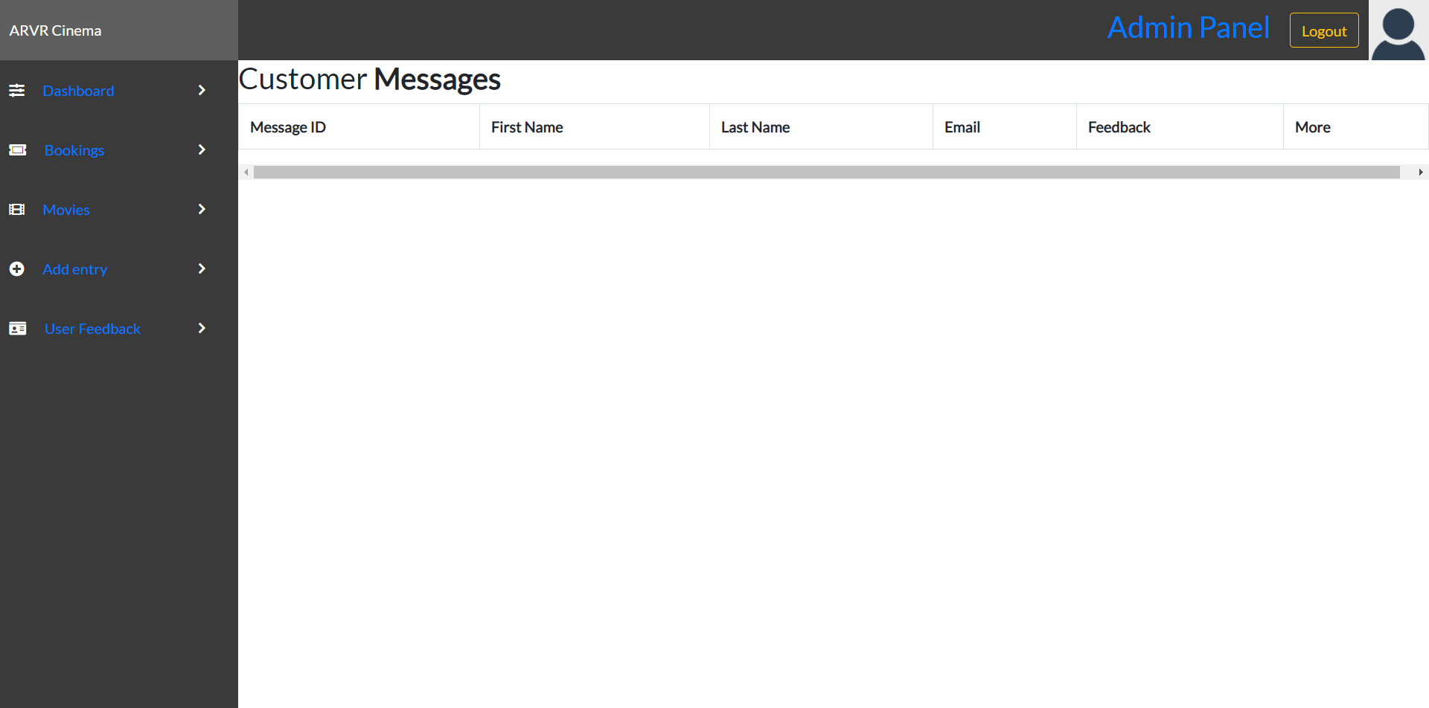

TECHNOLOGY STACK

Front Technologies:





HTML CSS JAVASCRIPT

Database Technologies:
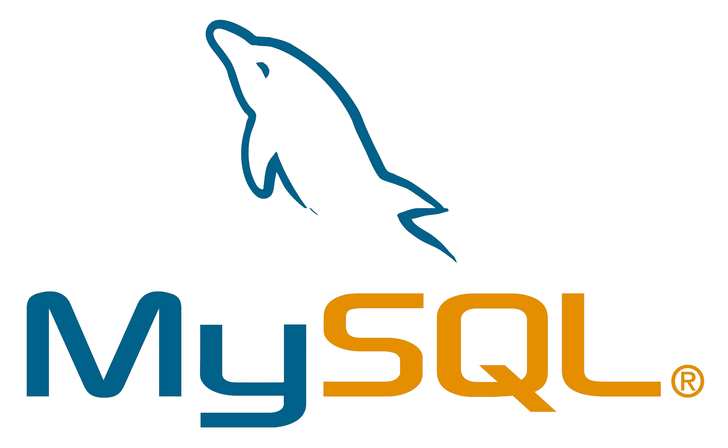


MySQL PHPMyAdmin

Backend Technologies:


PHP
CONCLUSION

In our project movie ticket booking system we have stored all information about the movies schedules and the users booking tickets and also status of availability of seats in particular theatre, movie, class type etc.This system will be helpful for the users want to book a movie tickets in an easiest available way also get information about the recent releases of the movies also get some small information about film. We have considered the most important requirements only for now,many more features and details can be added to our project in order to obtain even more user friendly applications.These applications are already in progress and in future they can be upgraded and may become part of amazing technology.

